Bike-Rental-prediction-model.R

r2058656

2023-07-23

library(tidyverse)

## ── Attaching core tidyverse packages ──────────────────────── tidyverse 2.0.0 ──  
## ✔ dplyr 1.1.2 ✔ readr 2.1.4  
## ✔ forcats 1.0.0 ✔ stringr 1.5.0  
## ✔ ggplot2 3.4.2 ✔ tibble 3.2.1  
## ✔ lubridate 1.9.2 ✔ tidyr 1.3.0  
## ✔ purrr 1.0.1   
## ── Conflicts ────────────────────────────────────────── tidyverse_conflicts() ──  
## ✖ dplyr::filter() masks stats::filter()  
## ✖ dplyr::lag() masks stats::lag()  
## ℹ Use the conflicted package (<http://conflicted.r-lib.org/>) to force all conflicts to become errors

library(lubridate)  
library(ggplot2)  
library(readxl)  
library(openxlsx)  
library(dplyr)  
library(caTools)  
library(pROC)

## Type 'citation("pROC")' for a citation.  
##   
## Attaching package: 'pROC'  
##   
## The following objects are masked from 'package:stats':  
##   
## cov, smooth, var

library(repr)  
library(car)

## Loading required package: carData  
##   
## Attaching package: 'car'  
##   
## The following object is masked from 'package:dplyr':  
##   
## recode  
##   
## The following object is masked from 'package:purrr':  
##   
## some

library(olsrr)

##   
## Attaching package: 'olsrr'  
##   
## The following object is masked from 'package:datasets':  
##   
## rivers

library(randomForest)

## randomForest 4.7-1.1  
## Type rfNews() to see new features/changes/bug fixes.  
##   
## Attaching package: 'randomForest'  
##   
## The following object is masked from 'package:dplyr':  
##   
## combine  
##   
## The following object is masked from 'package:ggplot2':  
##   
## margin

df = read_excel("bike.xlsx")  
head(df,n=3)

## # A tibble: 3 × 16  
## instant dteday season yr mnth holiday weekday workingday  
## <dbl> <dttm> <dbl> <dbl> <dbl> <dbl> <dbl> <dbl>  
## 1 1 2011-01-01 00:00:00 1 0 1 0 6 0  
## 2 2 2011-01-02 00:00:00 1 0 1 0 0 0  
## 3 3 2011-01-03 00:00:00 1 0 1 0 1 1  
## # ℹ 8 more variables: weathersit <dbl>, temp <dbl>, atemp <dbl>, hum <dbl>,  
## # windspeed <dbl>, casual <dbl>, registered <dbl>, cnt <dbl>

sapply(df, class)

## $instant  
## [1] "numeric"  
##   
## $dteday  
## [1] "POSIXct" "POSIXt"   
##   
## $season  
## [1] "numeric"  
##   
## $yr  
## [1] "numeric"  
##   
## $mnth  
## [1] "numeric"  
##   
## $holiday  
## [1] "numeric"  
##   
## $weekday  
## [1] "numeric"  
##   
## $workingday  
## [1] "numeric"  
##   
## $weathersit  
## [1] "numeric"  
##   
## $temp  
## [1] "numeric"  
##   
## $atemp  
## [1] "numeric"  
##   
## $hum  
## [1] "numeric"  
##   
## $windspeed  
## [1] "numeric"  
##   
## $casual  
## [1] "numeric"  
##   
## $registered  
## [1] "numeric"  
##   
## $cnt  
## [1] "numeric"

sapply(df, function(x) sum(is.na(x)))

## instant dteday season yr mnth holiday weekday   
## 0 0 0 0 0 0 0   
## workingday weathersit temp atemp hum windspeed casual   
## 0 0 0 0 0 0 0   
## registered cnt   
## 0 0

colnames(df)

## [1] "instant" "dteday" "season" "yr" "mnth"   
## [6] "holiday" "weekday" "workingday" "weathersit" "temp"   
## [11] "atemp" "hum" "windspeed" "casual" "registered"  
## [16] "cnt"

names(df)[2] <- "date"  
names(df)[9] <- "weather"  
names(df)[12] <- "humidity"  
names(df)[16] <- "count"  
colnames(df)

## [1] "instant" "date" "season" "yr" "mnth"   
## [6] "holiday" "weekday" "workingday" "weather" "temp"   
## [11] "atemp" "humidity" "windspeed" "casual" "registered"  
## [16] "count"

#options(repr.plot.width=4, repr.plot.height=3)

ggplot(data=df)+geom_bar(mapping=aes(x=workingday), fill = 'red')

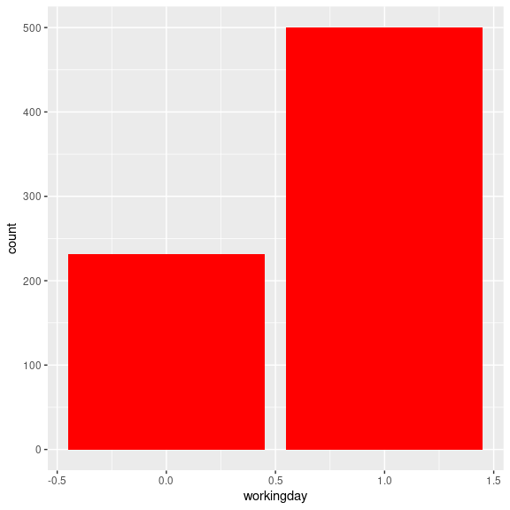

df_box <- df[,c(10,11,12,13)]  
head(df_box,n=3)

## # A tibble: 3 × 4  
## temp atemp humidity windspeed  
## <dbl> <dbl> <dbl> <dbl>  
## 1 0.344 0.364 0.806 0.160  
## 2 0.363 0.354 0.696 0.249  
## 3 0.196 0.189 0.437 0.248

options(repr.plot.width=6, repr.plot.height=6)

boxplot(df_box , main="Different boxplots",  
 col="blue",border="black")

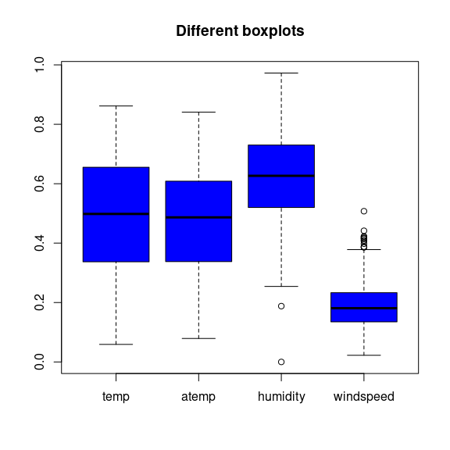

library("gridExtra")

##   
## Attaching package: 'gridExtra'

## The following object is masked from 'package:randomForest':  
##   
## combine

## The following object is masked from 'package:dplyr':  
##   
## combine

#options(repr.plot.width=14, repr.plot.height=6)

g1 <- ggplot(df, aes(x = casual)) + geom_histogram (fill="#69b3a2", color="#e9ecef" , binwidth = 400)  
g2 <- ggplot(df, aes(x = registered)) + geom_histogram (fill = "pink", color="#e9ecef" , binwidth = 400)  
g3 <- ggplot(df, aes(x = count)) + geom_histogram (fill = "blue", color="#e9ecef" , binwidth = 400)  
  
grid.arrange(g1, g2,g3, ncol = 3)

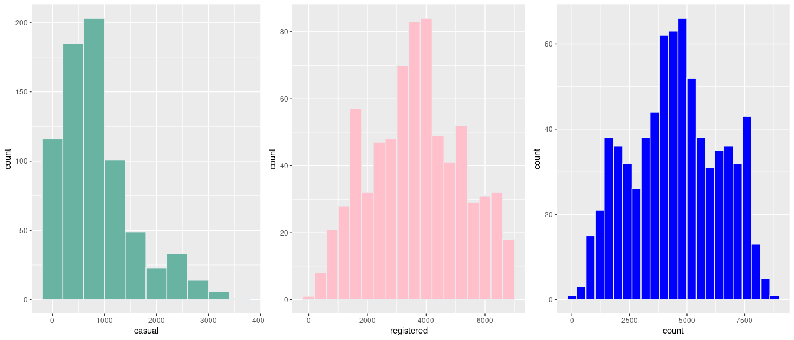

p <- ggplot(df, aes(x=date, y=count)) +  
 geom_line(color = "#00AFBB", size = 1)

## Warning: Using `size` aesthetic for lines was deprecated in ggplot2 3.4.0.  
## ℹ Please use `linewidth` instead.  
## This warning is displayed once every 8 hours.  
## Call `lifecycle::last_lifecycle_warnings()` to see where this warning was  
## generated.

p

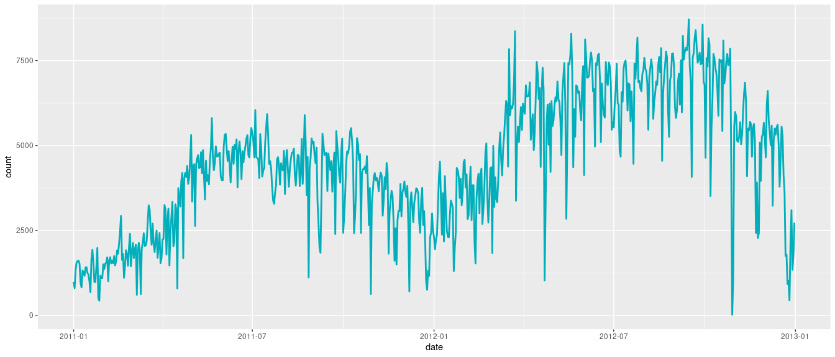

df_line = df  
head(df_line,3)

## # A tibble: 3 × 16  
## instant date season yr mnth holiday weekday workingday  
## <dbl> <dttm> <dbl> <dbl> <dbl> <dbl> <dbl> <dbl>  
## 1 1 2011-01-01 00:00:00 1 0 1 0 6 0  
## 2 2 2011-01-02 00:00:00 1 0 1 0 0 0  
## 3 3 2011-01-03 00:00:00 1 0 1 0 1 1  
## # ℹ 8 more variables: weather <dbl>, temp <dbl>, atemp <dbl>, humidity <dbl>,  
## # windspeed <dbl>, casual <dbl>, registered <dbl>, count <dbl>

df_line$holiday[df_line$holiday == 0] <- "No Holiday"  
df_line$holiday[df_line$holiday == 1] <- "Holiday"   
head(df_line,3)

## # A tibble: 3 × 16  
## instant date season yr mnth holiday weekday workingday  
## <dbl> <dttm> <dbl> <dbl> <dbl> <chr> <dbl> <dbl>  
## 1 1 2011-01-01 00:00:00 1 0 1 No Holiday 6 0  
## 2 2 2011-01-02 00:00:00 1 0 1 No Holiday 0 0  
## 3 3 2011-01-03 00:00:00 1 0 1 No Holiday 1 1  
## # ℹ 8 more variables: weather <dbl>, temp <dbl>, atemp <dbl>, humidity <dbl>,  
## # windspeed <dbl>, casual <dbl>, registered <dbl>, count <dbl>

p1 <- ggplot(df_line, aes(x=date, y=count)) + geom_line(aes(color = holiday), size = 1) + scale_color_manual(values = c("#00AFBB", "#E7B800"))+theme_minimal()  
p1

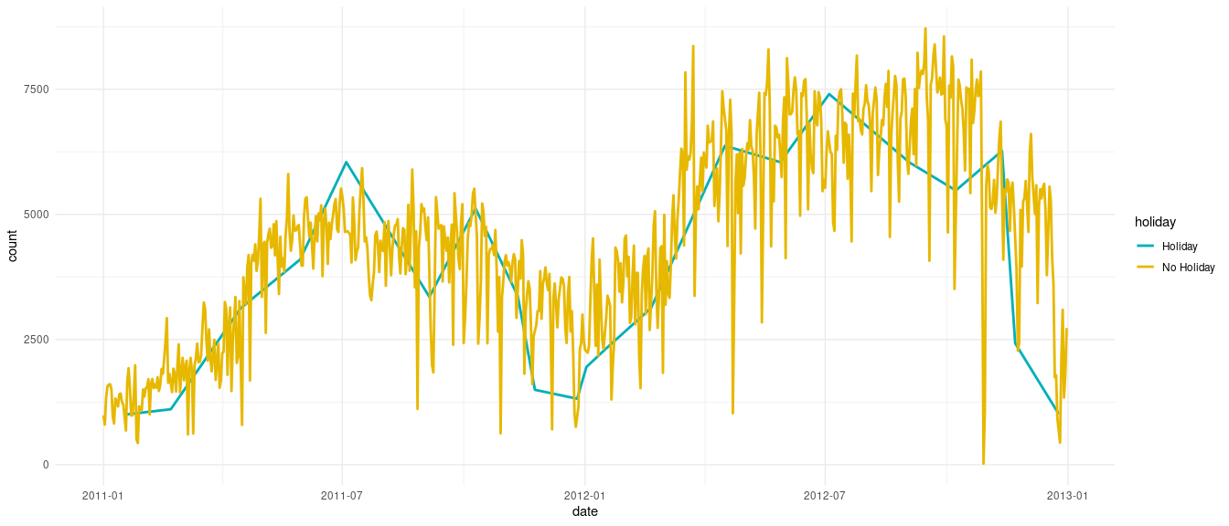

## Creating Prediction model  
df1 = df  
head(df1,n=7)

## # A tibble: 7 × 16  
## instant date season yr mnth holiday weekday workingday  
## <dbl> <dttm> <dbl> <dbl> <dbl> <dbl> <dbl> <dbl>  
## 1 1 2011-01-01 00:00:00 1 0 1 0 6 0  
## 2 2 2011-01-02 00:00:00 1 0 1 0 0 0  
## 3 3 2011-01-03 00:00:00 1 0 1 0 1 1  
## 4 4 2011-01-04 00:00:00 1 0 1 0 2 1  
## 5 5 2011-01-05 00:00:00 1 0 1 0 3 1  
## 6 6 2011-01-06 00:00:00 1 0 1 0 4 1  
## 7 7 2011-01-07 00:00:00 1 0 1 0 5 1  
## # ℹ 8 more variables: weather <dbl>, temp <dbl>, atemp <dbl>, humidity <dbl>,  
## # windspeed <dbl>, casual <dbl>, registered <dbl>, count <dbl>

df1$instant <- NULL  
df1$date <- NULL  
head(df1,n=2)

## # A tibble: 2 × 14  
## season yr mnth holiday weekday workingday weather temp atemp humidity  
## <dbl> <dbl> <dbl> <dbl> <dbl> <dbl> <dbl> <dbl> <dbl> <dbl>  
## 1 1 0 1 0 6 0 2 0.344 0.364 0.806  
## 2 1 0 1 0 0 0 2 0.363 0.354 0.696  
## # ℹ 4 more variables: windspeed <dbl>, casual <dbl>, registered <dbl>,  
## # count <dbl>

colnames(df1)

## [1] "season" "yr" "mnth" "holiday" "weekday"   
## [6] "workingday" "weather" "temp" "atemp" "humidity"   
## [11] "windspeed" "casual" "registered" "count"

#options(repr.plot.width=14, repr.plot.height=10)  
  
library(reshape2)

##   
## Attaching package: 'reshape2'

## The following object is masked from 'package:tidyr':  
##   
## smiths

# creating correlation matrix  
corr_mat <- round(cor(df1),2)  
   
# reduce the size of correlation matrix  
melted_corr_mat <- melt(corr_mat)  
head(melted_corr_mat)

## Var1 Var2 value  
## 1 season season 1.00  
## 2 yr season 0.00  
## 3 mnth season 0.83  
## 4 holiday season -0.01  
## 5 weekday season 0.00  
## 6 workingday season 0.01

# plotting the correlation heatmap

library(ggplot2)  
ggplot(data = melted_corr_mat, aes(x=Var1, y=Var2,  
 fill=value)) +  
geom_tile() +  
geom_text(aes(Var2, Var1, label = value),  
 color = "white", size = 4)

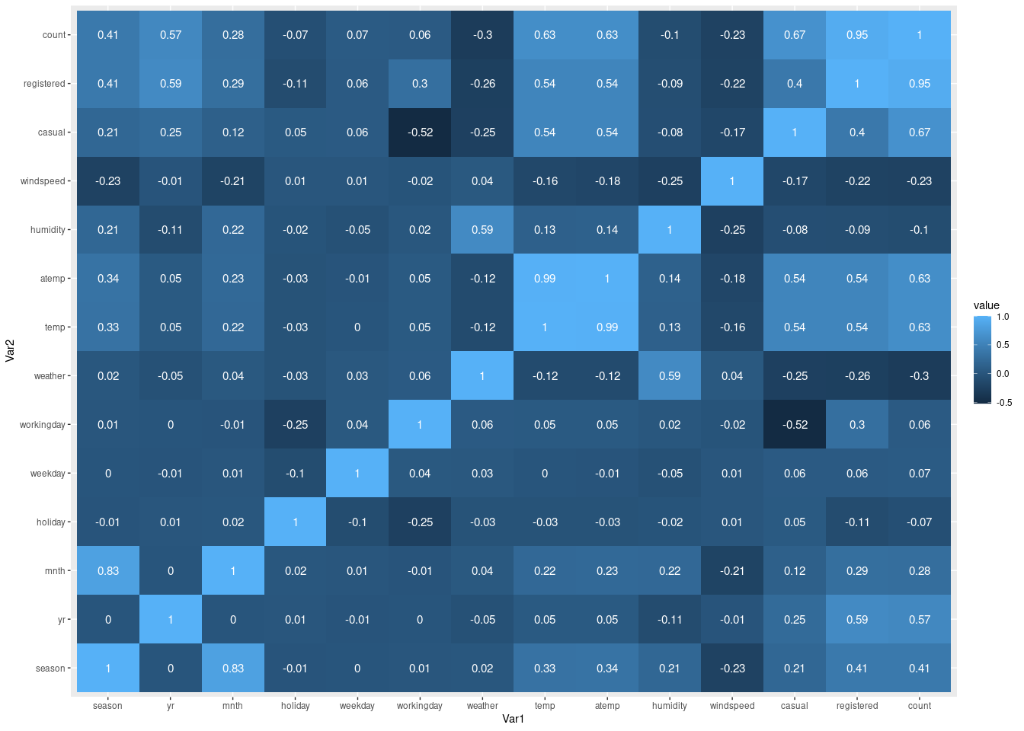

# Scaling the data  
  
df1 <- df1 %>% mutate_at(c('season' ,'yr', 'mnth', 'holiday', 'weekday', 'workingday', 'weather', 'temp', 'atemp', 'humidity', 'windspeed' ,'casual', 'registered'), ~(scale(.) %>% as.vector))  
head(df1,n=7)

## # A tibble: 7 × 14  
## season yr mnth holiday weekday workingday weather temp atemp humidity  
## <dbl> <dbl> <dbl> <dbl> <dbl> <dbl> <dbl> <dbl> <dbl> <dbl>  
## 1 -1.35 -1.00 -1.60 -0.172 1.50 -1.47 1.11 -0.826 -0.679 1.25   
## 2 -1.35 -1.00 -1.60 -0.172 -1.50 -1.47 1.11 -0.721 -0.740 0.479  
## 3 -1.35 -1.00 -1.60 -0.172 -0.996 0.679 -0.726 -1.63 -1.75 -1.34   
## 4 -1.35 -1.00 -1.60 -0.172 -0.497 0.679 -0.726 -1.61 -1.61 -0.263  
## 5 -1.35 -1.00 -1.60 -0.172 0.00136 0.679 -0.726 -1.47 -1.50 -1.34   
## 6 -1.35 -1.00 -1.60 -0.172 0.500 0.679 -0.726 -1.59 -1.48 -0.770  
## 7 -1.35 -1.00 -1.60 -0.172 0.999 0.679 1.11 -1.63 -1.63 -0.907  
## # ℹ 4 more variables: windspeed <dbl>, casual <dbl>, registered <dbl>,  
## # count <dbl>

set.seed(123)  
  
sample <- sample.split(df1$count, SplitRatio = 0.75)  
train <- subset(df1, sample == TRUE)  
test <- subset(df1, sample == FALSE)  
  
head(train , 3)

## # A tibble: 3 × 14  
## season yr mnth holiday weekday workingday weather temp atemp humidity  
## <dbl> <dbl> <dbl> <dbl> <dbl> <dbl> <dbl> <dbl> <dbl> <dbl>  
## 1 -1.35 -1.00 -1.60 -0.172 1.50 -1.47 1.11 -0.826 -0.679 1.25   
## 2 -1.35 -1.00 -1.60 -0.172 -0.996 0.679 -0.726 -1.63 -1.75 -1.34   
## 3 -1.35 -1.00 -1.60 -0.172 0.500 0.679 -0.726 -1.59 -1.48 -0.770  
## # ℹ 4 more variables: windspeed <dbl>, casual <dbl>, registered <dbl>,  
## # count <dbl>

head(test , 3)

## # A tibble: 3 × 14  
## season yr mnth holiday weekday workingday weather temp atemp humidity  
## <dbl> <dbl> <dbl> <dbl> <dbl> <dbl> <dbl> <dbl> <dbl> <dbl>  
## 1 -1.35 -1.00 -1.60 -0.172 -1.50 -1.47 1.11 -0.721 -0.740 0.479  
## 2 -1.35 -1.00 -1.60 -0.172 -0.497 0.679 -0.726 -1.61 -1.61 -0.263  
## 3 -1.35 -1.00 -1.60 -0.172 0.00136 0.679 -0.726 -1.47 -1.50 -1.34   
## # ℹ 4 more variables: windspeed <dbl>, casual <dbl>, registered <dbl>,  
## # count <dbl>

dim(train)

## [1] 548 14

dim(test)

## [1] 183 14

# Random forest Model  
  
rf_fit <- randomForest(count ~ casual + registered , data = train, ntree=1000,  
 keep.forest=FALSE, importance=TRUE)  
print(rf_fit)

##   
## Call:  
## randomForest(formula = count ~ casual + registered, data = train, ntree = 1000, keep.forest = FALSE, importance = TRUE)   
## Type of random forest: regression  
## Number of trees: 1000  
## No. of variables tried at each split: 1  
##   
## Mean of squared residuals: 17326.26  
## % Var explained: 99.51

model <- lm(count ~., data = train)  
summary(model)

## Warning in summary.lm(model): essentially perfect fit: summary may be  
## unreliable

##   
## Call:  
## lm(formula = count ~ ., data = train)  
##   
## Residuals:  
## Min 1Q Median 3Q Max   
## -1.029e-11 -3.060e-13 -1.400e-14 2.530e-13 4.805e-11   
##   
## Coefficients:  
## Estimate Std. Error t value Pr(>|t|)   
## (Intercept) 4.504e+03 9.856e-14 4.570e+16 < 2e-16 ***  
## season -7.411e-14 2.021e-13 -3.670e-01 0.71397   
## yr 4.882e-13 1.651e-13 2.957e+00 0.00324 **   
## mnth 1.760e-13 1.872e-13 9.400e-01 0.34763   
## holiday 1.454e-13 9.754e-14 1.491e+00 0.13662   
## weekday 2.362e-13 1.011e-13 2.337e+00 0.01983 *   
## workingday 5.981e-14 1.738e-13 3.440e-01 0.73085   
## weather 3.869e-13 1.386e-13 2.791e+00 0.00544 **   
## temp -5.882e-13 7.167e-13 -8.210e-01 0.41221   
## atemp 5.330e-13 7.248e-13 7.350e-01 0.46244   
## humidity 4.037e-13 1.427e-13 2.828e+00 0.00486 **   
## windspeed -1.064e-14 1.108e-13 -9.600e-02 0.92352   
## casual 6.866e+02 1.850e-13 3.712e+15 < 2e-16 ***  
## registered 1.560e+03 2.436e-13 6.404e+15 < 2e-16 ***  
## ---  
## Signif. codes: 0 '***' 0.001 '**' 0.01 '*' 0.05 '.' 0.1 ' ' 1  
##   
## Residual standard error: 2.303e-12 on 534 degrees of freedom  
## Multiple R-squared: 1, Adjusted R-squared: 1   
## F-statistic: 2.808e+31 on 13 and 534 DF, p-value: < 2.2e-16

# Linear regression model   
  
model2 <- lm(count ~ casual + registered , data = train)  
summary(model2)

## Warning in summary.lm(model2): essentially perfect fit: summary may be  
## unreliable

##   
## Call:  
## lm(formula = count ~ casual + registered, data = train)  
##   
## Residuals:  
## Min 1Q Median 3Q Max   
## -1.584e-12 -3.940e-13 -1.600e-13 3.000e-14 4.512e-11   
##   
## Coefficients:  
## Estimate Std. Error t value Pr(>|t|)   
## (Intercept) 4.504e+03 1.182e-13 3.810e+16 <2e-16 ***  
## casual 6.866e+02 1.292e-13 5.313e+15 <2e-16 ***  
## registered 1.560e+03 1.302e-13 1.198e+16 <2e-16 ***  
## ---  
## Signif. codes: 0 '***' 0.001 '**' 0.01 '*' 0.05 '.' 0.1 ' ' 1  
##   
## Residual standard error: 2.768e-12 on 545 degrees of freedom  
## Multiple R-squared: 1, Adjusted R-squared: 1   
## F-statistic: 1.264e+32 on 2 and 545 DF, p-value: < 2.2e-16

pred <- predict(model2,test)  
  
df_test = test  
df_test$New_count = pred  
head(df_test,n=7)

## # A tibble: 7 × 15  
## season yr mnth holiday weekday workingday weather temp atemp humidity  
## <dbl> <dbl> <dbl> <dbl> <dbl> <dbl> <dbl> <dbl> <dbl> <dbl>  
## 1 -1.35 -1.00 -1.60 -0.172 -1.50 -1.47 1.11 -0.721 -0.740 0.479  
## 2 -1.35 -1.00 -1.60 -0.172 -0.497 0.679 -0.726 -1.61 -1.61 -0.263  
## 3 -1.35 -1.00 -1.60 -0.172 0.00136 0.679 -0.726 -1.47 -1.50 -1.34   
## 4 -1.35 -1.00 -1.60 -0.172 1.50 -1.47 1.11 -1.80 -1.92 -0.646  
## 5 -1.35 -1.00 -1.60 -0.172 -0.497 0.679 1.11 -1.78 -1.74 0.411  
## 6 -1.35 -1.00 -1.60 -0.172 -1.50 -1.47 -0.726 -1.44 -1.47 -1.01   
## 7 -1.35 -1.00 -1.60 -0.172 0.500 0.679 1.11 -1.28 -1.35 -0.629  
## # ℹ 5 more variables: windspeed <dbl>, casual <dbl>, registered <dbl>,  
## # count <dbl>, New_count <dbl>

g1 = ggplot(df_test, aes(x = count, y = New_count)) +  
 geom_point() + stat_smooth(method = "lm",  
 col = "#C42126",  
 se = FALSE,  
 size = 1)  
g1

## `geom_smooth()` using formula = 'y ~ x'

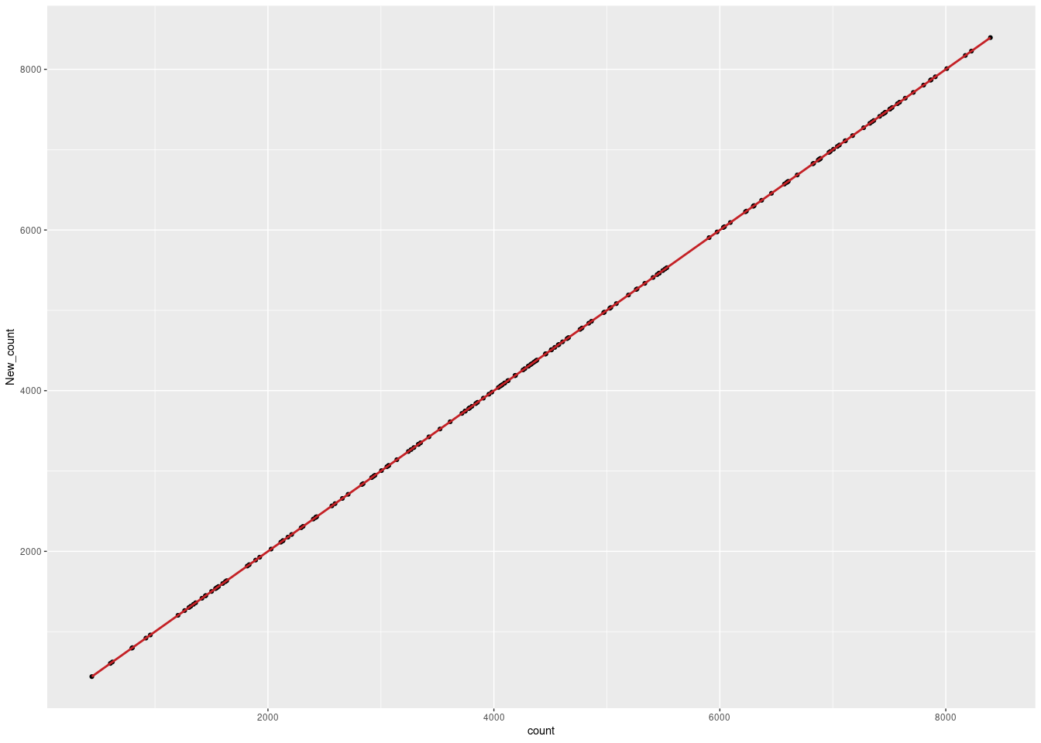

# Regression Assumptions Check  
  
# 1. Linearity  
plot(df$casual , df$count)  
#lines(lowess(df$casual,df$count), col = "blue")  
abline(lm(count~casual,data=df),col='red')

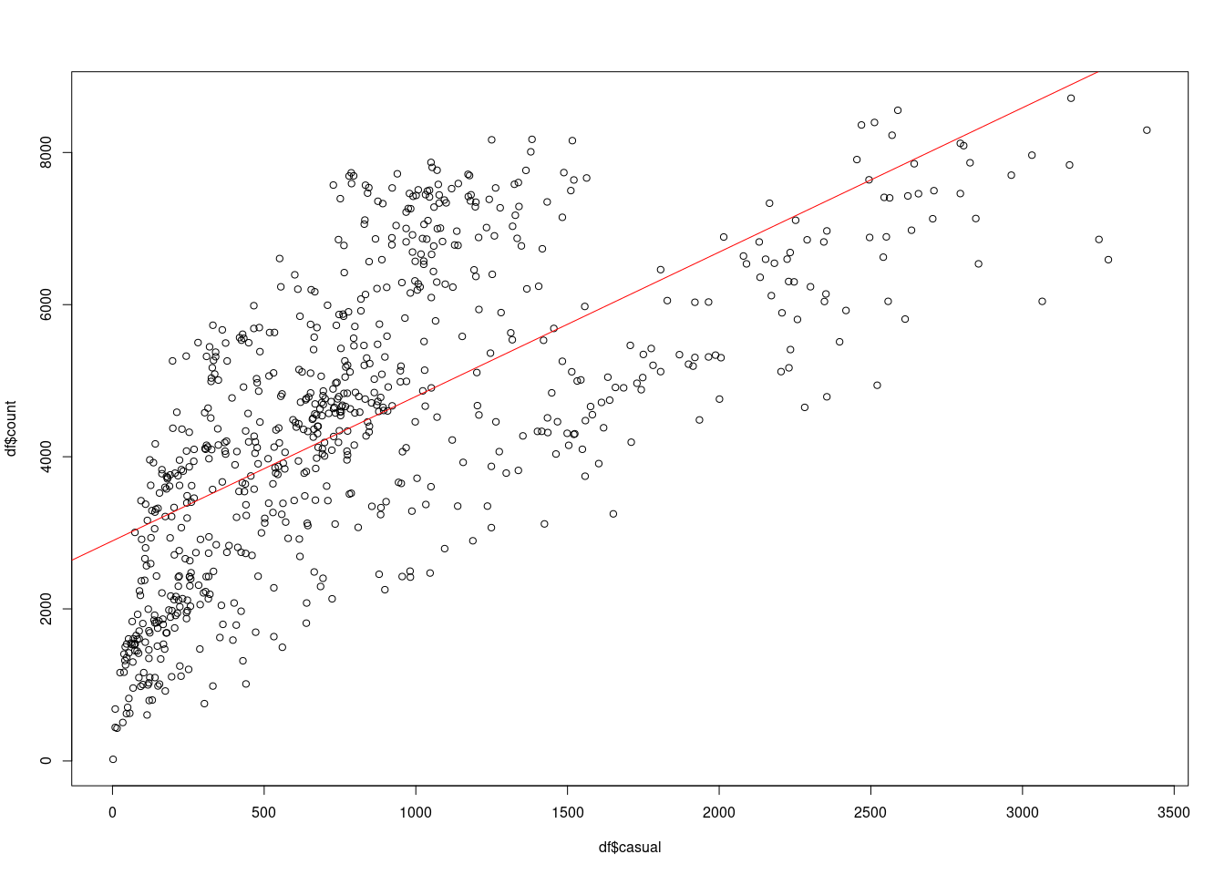

plot(df$registered , df$count)  
#lines(lowess(df$casual,df$count), col = "blue")  
abline(lm(count~registered,data=df),col='green' , lwd = 5)

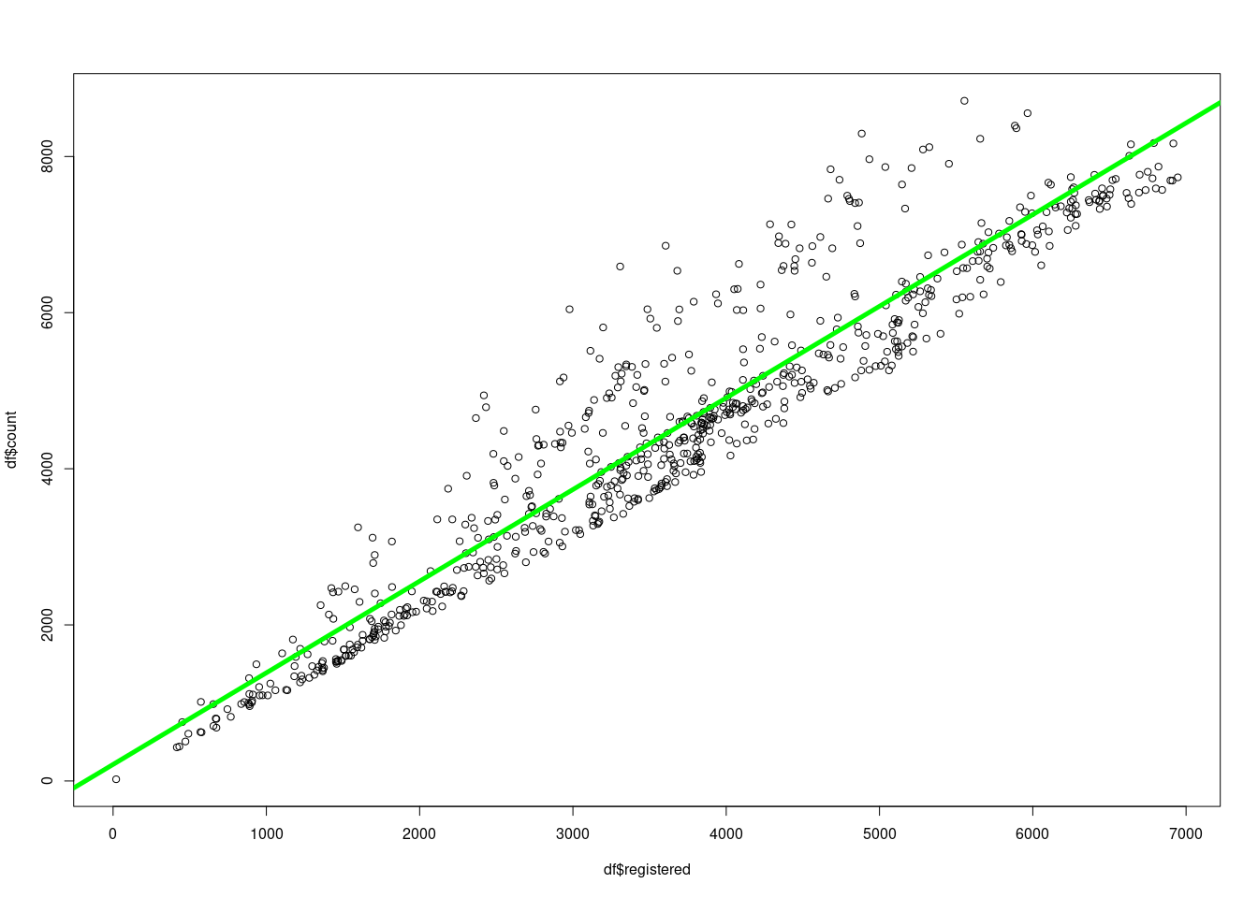

# 2 . Multicollinearity  
  
vif(model2)

## Warning in summary.lm(object, ...): essentially perfect fit: summary may be  
## unreliable

## casual registered   
## 1.156225 1.156225

cor(df$registered, df$casual , method = "pearson", use = "complete.obs")

## [1] 0.3952825

#3. Normality of residuals  
  
shapiro.test(model2$residuals)

##   
## Shapiro-Wilk normality test  
##   
## data: model2$residuals  
## W = 0.12057, p-value < 2.2e-16

hist(model2$residuals)

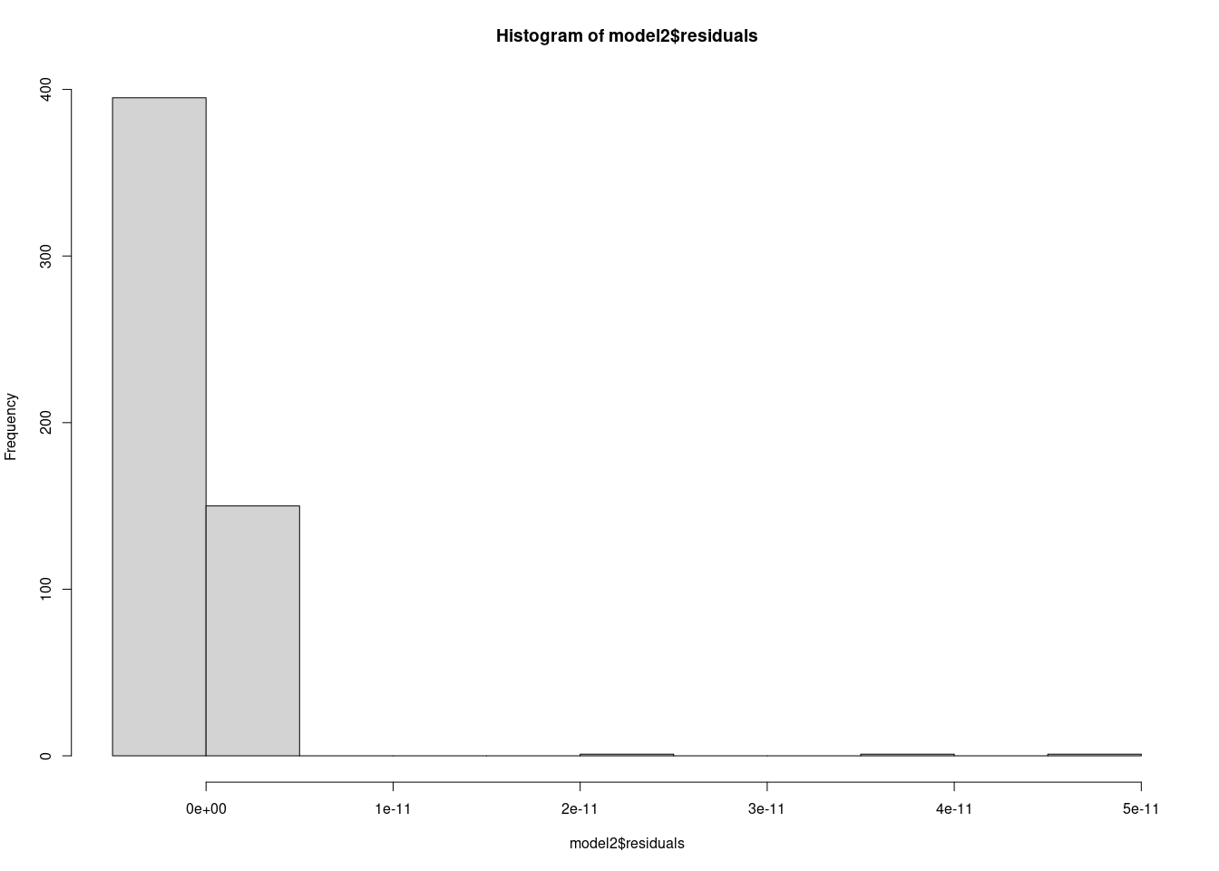

#4. Autocorrelation test  
  
durbinWatsonTest(model2)

## Warning in summary.lm(model): essentially perfect fit: summary may be  
## unreliable

## lag Autocorrelation D-W Statistic p-value  
## 1 0.4703985 0.5715503 0  
## Alternative hypothesis: rho != 0

#5. Heteroscedasticity test  
  
ols_test_score(model2)

##   
## Score Test for Heteroskedasticity  
## ---------------------------------  
## Ho: Variance is homogenous  
## Ha: Variance is not homogenous  
##   
## Variables: fitted values of count   
##   
## Test Summary   
## -----------------------------  
## DF = 1   
## Chi2 = 7.634114   
## Prob > Chi2 = 0.00572745